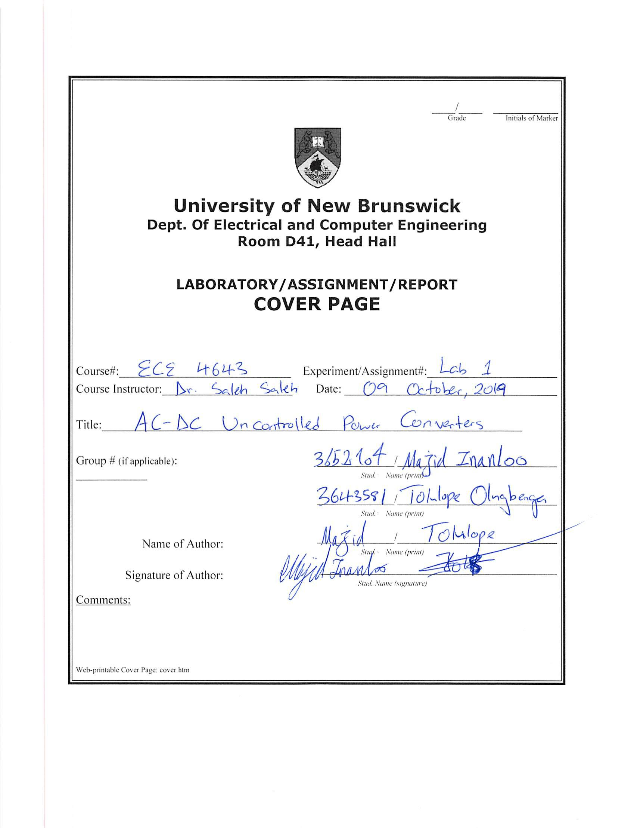

**Table of Contents**

1 Objective of This Experiment 4

2 The One-Phase Full Wave Rectifier 4

2.1 200 Ohm Resistor 5

2.1.1 Waveforms of voltages and currents for 200 Ω load – 1 phase 5

2.1.2 Measures of active and reactive powers for 200 Ω - 1 phase 5

2.1.3 Harmonic spectrums of input current, output current and output voltage for 200 Ω – 1 phase 6

2.2 DC Motor 7

2.2.1 Waveforms of voltages and currents for DC motor – 1 phase 7

2.2.2 Measures of active and reactive powers for DC motor - 1 phase 8

2.2.3 Harmonic spectrums of input current, output current and output voltage for the DC motor – 1 phase 8

3 The Three-Phase Full Wave Rectifier 10

3.1 200 Ohm Resistor 11

3.1.1 Waveforms of voltages and currents for 200 Ω load – 3 phase 11

3.1.2 Measures of active and reactive powers for 200 Ω - 3 phase 11

3.1.3 Harmonic spectrums of input current, output current and output voltage for 200 Ω – 3 phase 12

3.2 DC Motor 13

3.2.1 Waveforms of voltages and currents for DC motor – 3 phase 13

3.2.2 Measures of active and reactive powers for DC motor - 3 phase 14

3.2.3 Harmonic spectrums of input current, output current and output voltage for the DC motor– 3 phase 15

4 Calculations and Questions 16

4.1 Input Power Calculations 16

4.2 Efficiency Calculations 17

4.3 Efficiency Comparison 17

4.4 Power Losses Calculations 17

5 Conclusions 18

**List of Figures**

Figure 1:- The figure shows a one phase full-wave rectifier and both load types 4

Figure 2:- The figure shows the waveforms of the input/output voltage and current for the 200 Ω resistor - 1phase 5

Figure 3:- The figures on the left and right shows the input/output of the active and reactive power respectively, for the 200 Ω resistor. 5

Figure 4:- The figure shows the harmonics of input current for 200 Ω load - 1phase 6

Figure 5:- The figure shows the harmonics of output current for 200 Ω load - 1phase 6

Figure 6:- The figure shows the harmonics of output voltage for 200 Ω load - 1phase 7

Figure 7:- The figure shows the waveforms of the input/output voltage and current for the DC motor - 1phase 7

Figure 8:- The figures on the left and right shows the input/output of the active and reactive power respectively, for the DC motor. 8

Figure 9:- The figure shows the harmonics of the input current for the DC motor - 1phase 8

Figure 10:- The figure shows the harmonics of the output current for the DC motor - 1phase 9

Figure 11:- The figure shows the harmonics of the output voltage for the DC motor - 1phase 9

Figure 12:- The figure shows a three phase full-wave rectifier and both load types 10

Figure 13:- The figure shows the waveforms of the input/output voltage and current for the 200 Ω resistor – 3 phase 11

Figure 14:- The figures on the left and right shows the input/output of the active and reactive power respectively, for the 200 Ω resistor. 11

Figure 15:- The figure shows the harmonics of input current for 200 Ω load – 3 phase 12

Figure 16:- The figure shows the harmonics of output current for 200 Ω load – 3 phase 12

Figure 17:- The figure shows the harmonics of output voltage for 200 Ω load – 3 phase 13

Figure 18:- The figure shows the waveforms of the input voltage and current for the DC motor – 3 phase 13

Figure 19:- The figure shows the waveforms of the output voltage and current for the DC motor – 3 phase 14

Figure 20:- The figures on the left and right shows the input/output of the active and reactive power respectively, for the DC motor. 14

Figure 21:- The figure shows the harmonics of the input current for the DC motor – 3 phase 15

Figure 22:- The figure shows the harmonics of the output current for the DC motor – 3 phase 15

Figure 23:- The figure shows the harmonics of the output voltage for the DC motor – 3 phase 16

**List of Tables**

Table 1:- The table shows the calculations for the input power factor 16

Table 2:- The table shows the calculations for the efficiency 17

Table 3:– The table shows the calculations of the Power Losses 18

# 1 Objective of This Experiment

The aim of this experiment was to examine the performance of the single and three phase full wave rectifiers when supplying to different load types. The performance measures considered include; the harmonics on the input/output side of the converter, the input power factor, and the efficiency of the tested AC-DC rectifiers.

# 2 The One-Phase Full Wave Rectifier

The figure below shows the circuit for the one phase full wave rectifier. For this experiment, we used the data acquistion module (DAM) to observe and record; the input/output currents, input/output voltages, and the active & reactive power. Due to the rectifiers used in the rectification process, we will observe different harmonics for the input/output currents and voltages. First, the experiment was conducted using a 200 ohm resistor with an input voltage 60V; then the resistor was replaced using a DC motor with an input voltage 110V. By setting the firing angle to zero (α=0) the rectifier behaves like a diode.

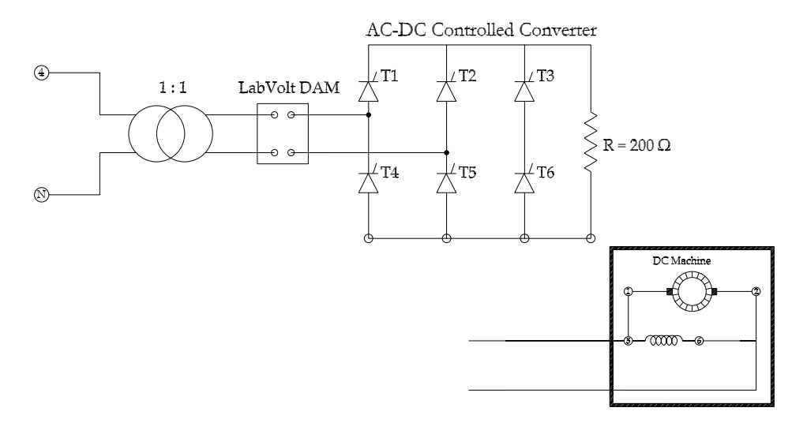

Figure :- The figure shows a one phase full-wave rectifier and both load types

## 2.1 200 Ohm Resistor

### 2.1.1 Waveforms of voltages and currents for 200 Ω load – 1 phase

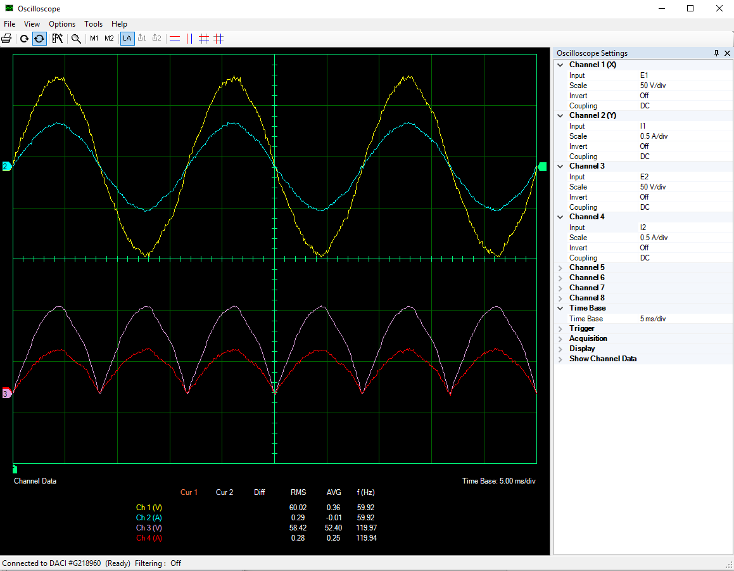

Figure :- The figure shows the waveforms of the input/output voltage and current for the 200 Ω resistor - 1phase

### 2.1.2 Measures of active and reactive powers for 200 Ω - 1 phase

Figure :- The figures on the left and right shows the input/output of the active and reactive power respectively, for the 200 Ω resistor.

### 2.1.3 Harmonic spectrums of input current, output current and output voltage for 200 Ω – 1 phase

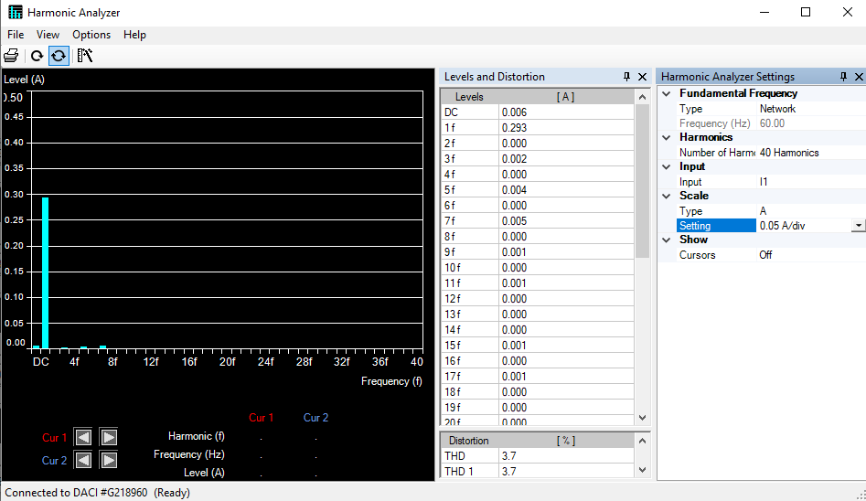

Figure :- The figure shows the harmonics of input current for 200 Ω load - 1phase

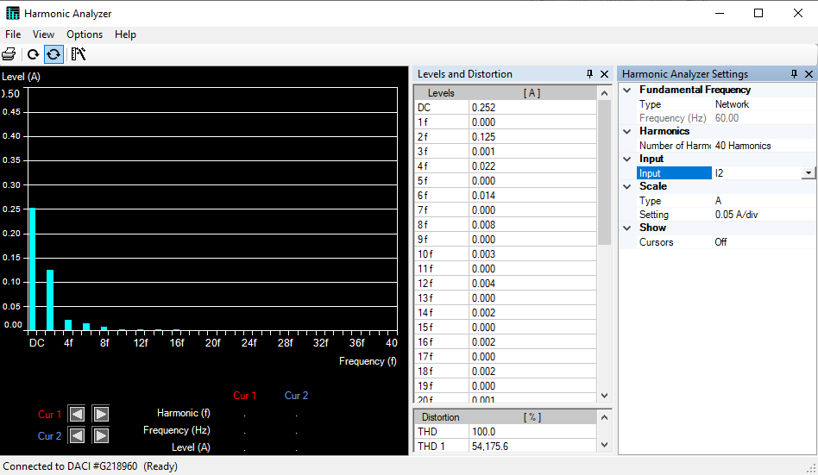

Figure :- The figure shows the harmonics of output current for 200 Ω load - 1phase

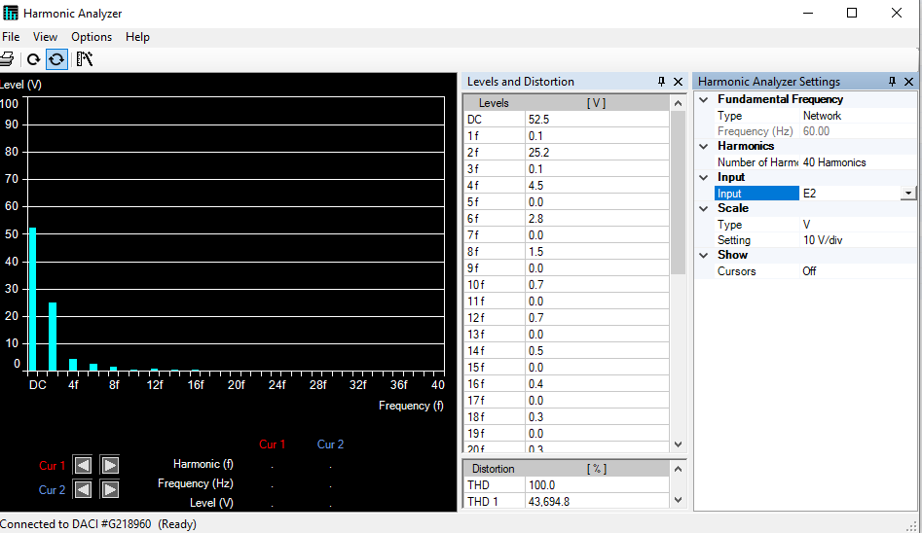

Figure :- The figure shows the harmonics of output voltage for 200 Ω load - 1phase

## 2.2 DC Motor

### 2.2.1 Waveforms of voltages and currents for DC motor – 1 phase

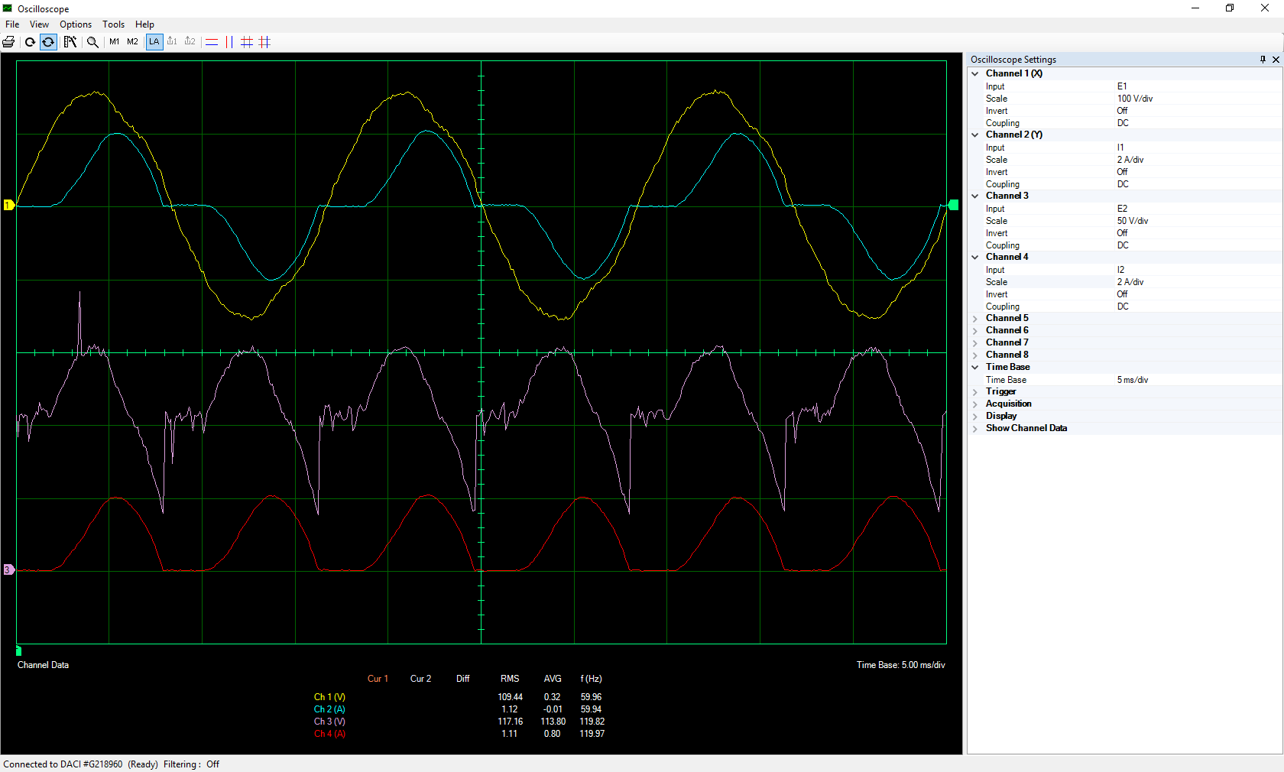

Figure :- The figure shows the waveforms of the input/output voltage and current for the DC motor - 1phase

### 2.2.2 Measures of active and reactive powers for DC motor - 1 phase

Figure :- The figures on the left and right shows the input/output of the active and reactive power respectively, for the DC motor.

### 2.2.3 Harmonic spectrums of input current, output current and output voltage for the DC motor – 1 phase

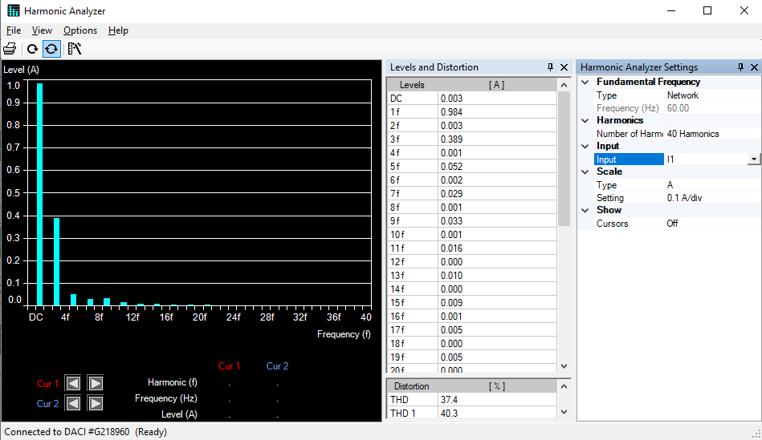

Figure :- The figure shows the harmonics of the input current for the DC motor - 1phase

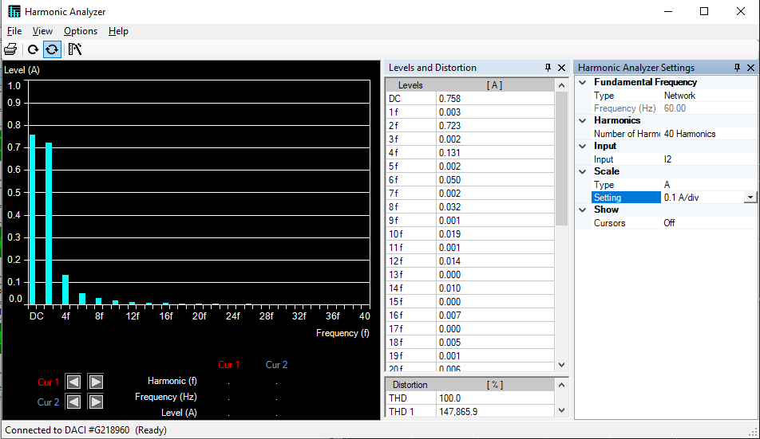

Figure :- The figure shows the harmonics of the output current for the DC motor - 1phase

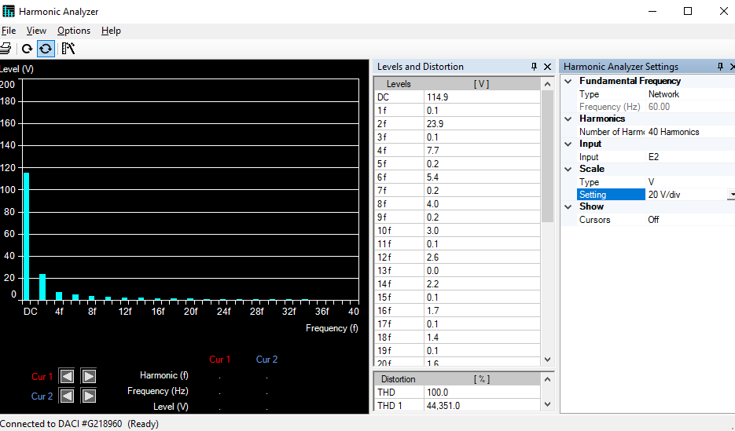

Figure :- The figure shows the harmonics of the output voltage for the DC motor - 1phase

# 3 The Three-Phase Full Wave Rectifier

The figure below shows the circuit for the three phase full wave rectifier. We used the data acquistion module (DAM) to observe and record; the input/output currents, input/output voltages, and the active & reactive power. First, the experiment was also conducted using a 200 ohm resistor with an input voltage 60V; then the resistor was replaced using a DC motor with an input voltage 110V. By setting the firing angle to zero (α=0) the rectifier behaves like a diode.

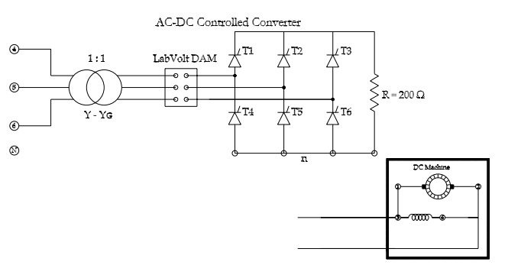

Figure :- The figure shows a three phase full-wave rectifier and both load types

## 3.1 200 Ohm Resistor

### 3.1.1 Waveforms of voltages and currents for 200 Ω load – 3 phase

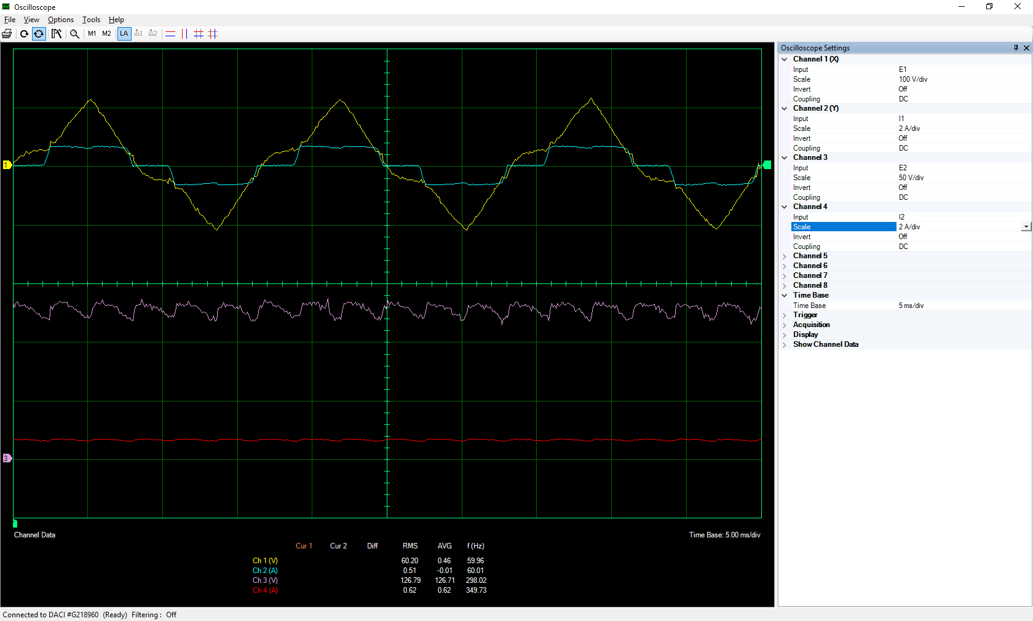

Figure :- The figure shows the waveforms of the input/output voltage and current for the 200 Ω resistor – 3 phase

### 3.1.2 Measures of active and reactive powers for 200 Ω - 3 phase

Figure :- The figures on the left and right shows the input/output of the active and reactive power respectively, for the 200 Ω resistor.

### 3.1.3 Harmonic spectrums of input current, output current and output voltage for 200 Ω – 3 phase

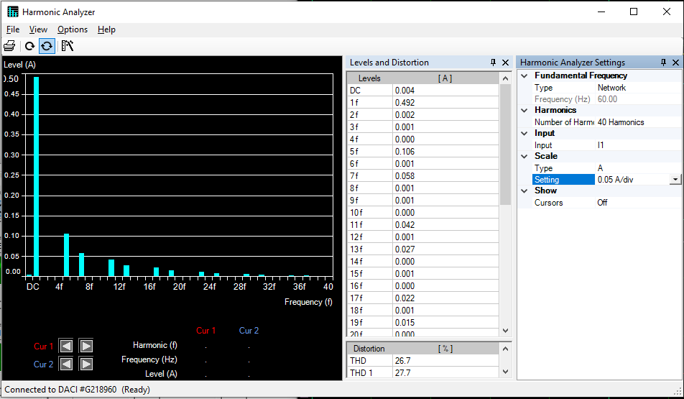

Figure :- The figure shows the harmonics of input current for 200 Ω load – 3 phase

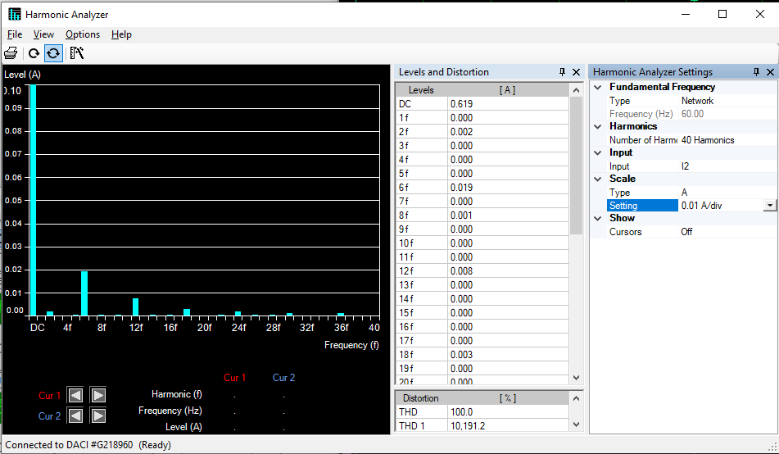

Figure :- The figure shows the harmonics of output current for 200 Ω load – 3 phase

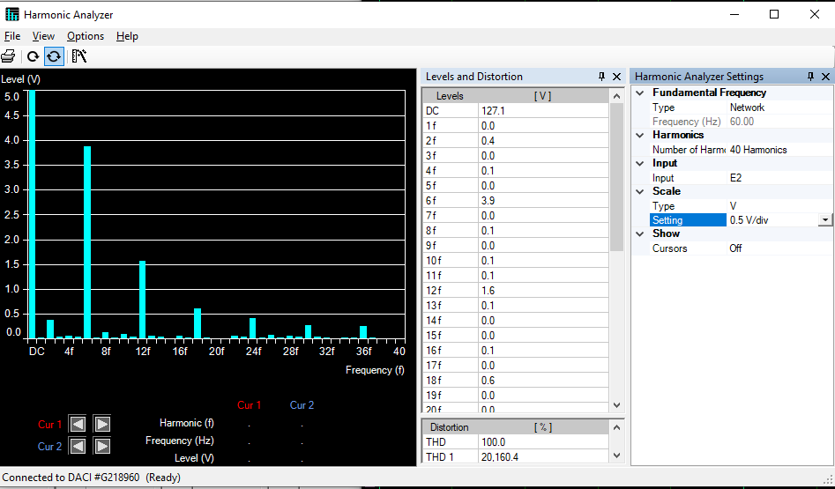

Figure :- The figure shows the harmonics of output voltage for 200 Ω load – 3 phase

## 3.2 DC Motor

### 3.2.1 Waveforms of voltages and currents for DC motor – 3 phase

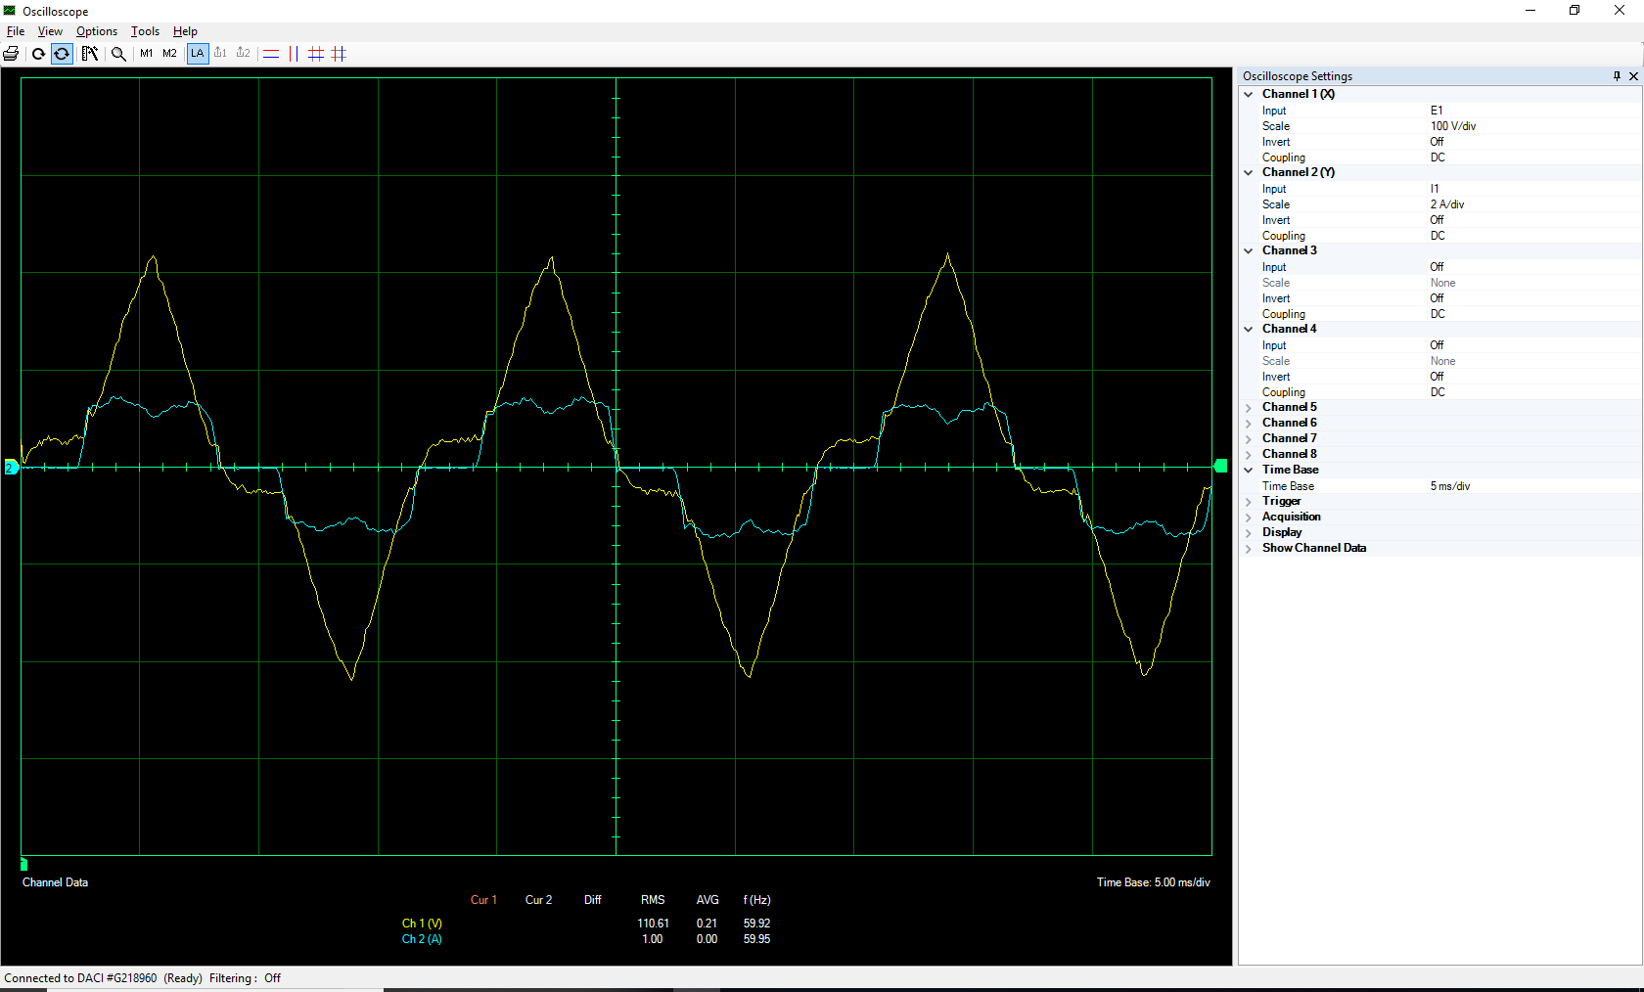

Figure :- The figure shows the waveforms of the input voltage and current for the DC motor – 3 phase

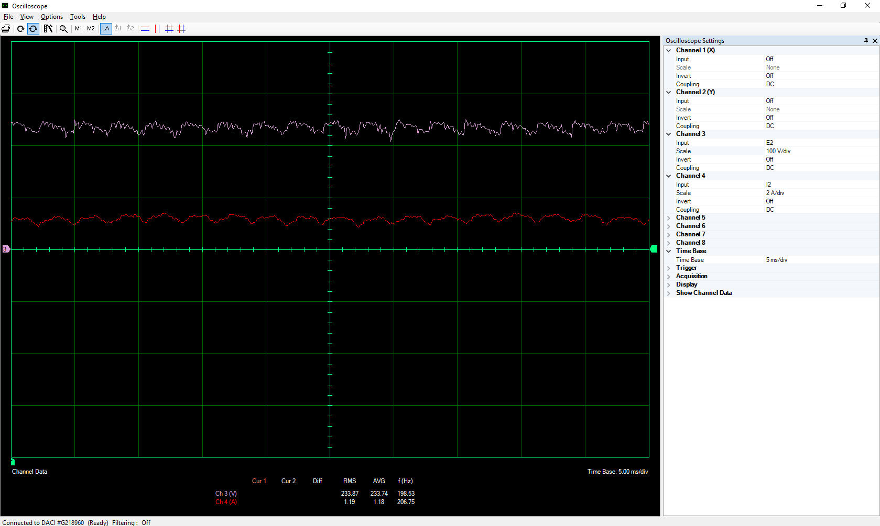

Figure :- The figure shows the waveforms of the output voltage and current for the DC motor – 3 phase

### 3.2.2 Measures of active and reactive powers for DC motor - 3 phase

Figure :- The figures on the left and right shows the input/output of the active and reactive power respectively, for the DC motor.

### 3.2.3 Harmonic spectrums of input current, output current and output voltage for the DC motor– 3 phase

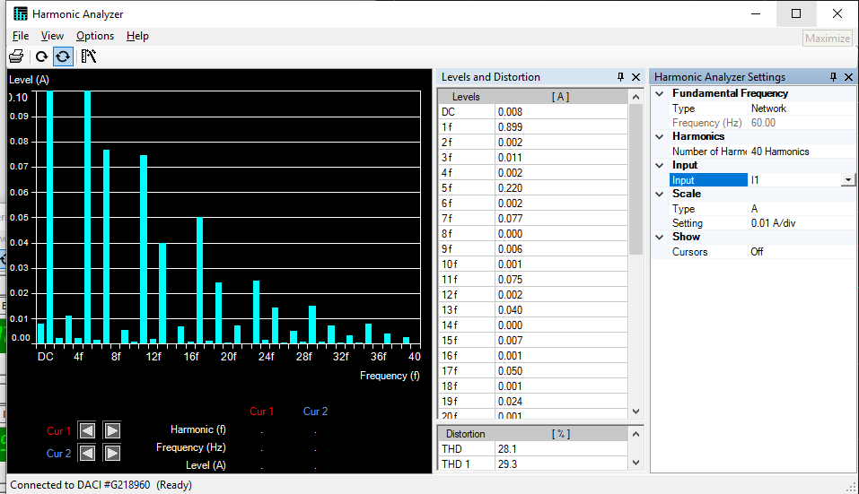

Figure :- The figure shows the harmonics of the input current for the DC motor – 3 phase

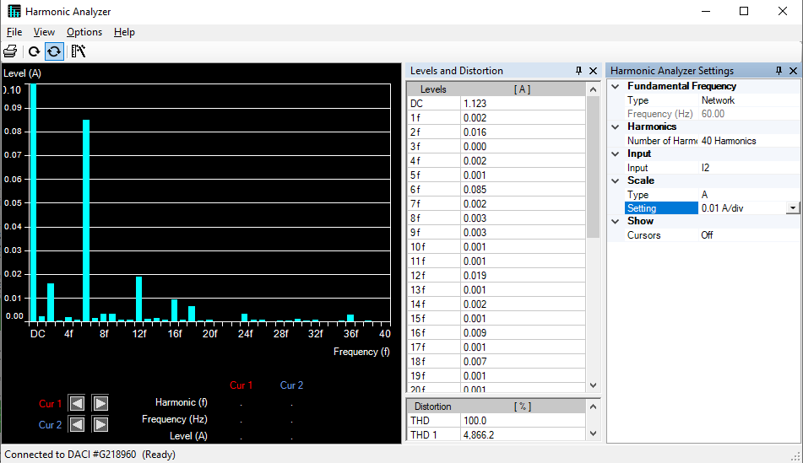

Figure :- The figure shows the harmonics of the output current for the DC motor – 3 phase

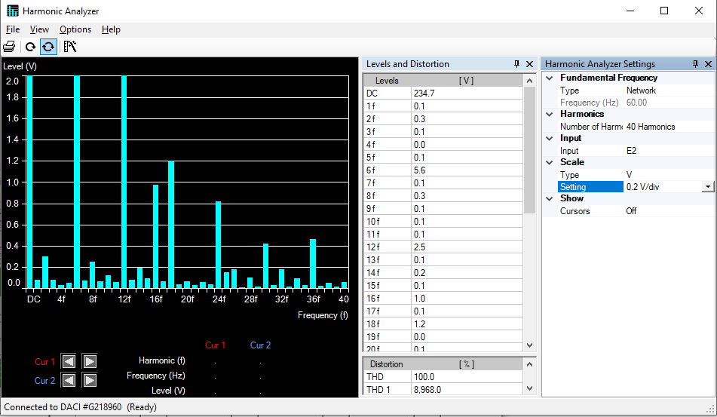

Figure :- The figure shows the harmonics of the output voltage for the DC motor – 3 phase

# 4 Calculations and Questions

## 4.1 Input Power Calculations

The power factor can be obtained according to following equations:

|  |  |  |  |  |  |
| --- | --- | --- | --- | --- | --- |
| **Rectifier type** | **Load type** | **P (W)** | **Q (Var)** | **S (VA)** | **Power factor** |
| **1 phase** | 200 Ω | 17.32 | -0.044 | 17.32 | 1 |
| Dc motor | 100.6 | 47.72 | 111.34 | 0.9035 |
| **3 phase** | 200 Ω | 28.35×3=85.05 | 3.287×3=9.861 | 85.62 | 0.9933 |
| Dc motor | 94.64×3=283.92 | 9.504×3=28.512 | 285.35 | 0.995 |



Table 1:- The table shows the calculations for the input power factor

## 4.2 Efficiency Calculations

Efficiency can be calculated as follow:



|  |  |  |  |  |
| --- | --- | --- | --- | --- |
| **Rectifier type** | **Load type** | **Pdc (W)** | **Pin  (W)** |  |
| **1 phase** | 200 Ω | 16.10 | 17.32 | 0.9295 |
| Dc motor | 96.36 | 100.6 | 0.9578 |
| **3 phase** | 200 Ω | 78.32 | 28.35×3=85.05 | 0.9208 |
| Dc motor | 272.2 | 94.64×3=283.92 | 0.9587 |

Table 2:- The table shows the calculations for the efficiency

## 4.3 Efficiency Comparison

It is obvious that the power of 3-phase system is more than that of the single phase rectifier. Therefore, as we can see on Table 2, the efficiency was more in 3-phase than in the single phase. In addition, the ripple factor according to the harmonic spectrums was less in the 3-phase. We would also like to take into account that there can some errors due to our equipment used in the experiment. Finally, comparing the 200 ohm resistive load and the DC motor load; we can see from Table 2 above that, the DC motor load had more efficiency than the resistive load.

## 4.4 Power Losses Calculations

Power loss can be obtained from following equation:



|  |  |  |  |  |
| --- | --- | --- | --- | --- |
| **Rectifier type** | **Load type** | **Pdc (W)** | **Pin (W)** | **Ploss (W)** |
| **1 phase** | 200 Ω | 16.10 | 17.32 | 1.22 |
| Dc motor | 96.36 | 100.6 | 4.24 |
| **3 phase** | 200 Ω | 78.32 | 28.35×3=85.05 | 6.73 |
| Dc motor | 272.2 | 94.64×3=283.92 | 11.72 |

Table 3:– The table shows the calculations of the Power Losses

# 5 Conclusions

From the results for the single phase and the 3 phase full-wave rectifiers, we can see that the input voltage and the load type have different impacts on the efficiency. As seen on Table 2 above we can conclude that; by changing the resistive load to the DC motor load and increasing the input voltage, there will be a rise in the efficiency. This conclusion is effective on both the single phase and the 3 phase system. In addition, according to harmonics spectrum and the Y-YG connection of the transformer, we experienced less harmonics in the 3-phase as compared to the single phase for both loads; this made the waveform of the output voltage and current to have less ripples. Furthermore, the power losses are more in the DC motor as compared to that of the resistive load; this is because the DC motor has an inductive load.